***Universidad Nacional de Santiago del Estero Facultad de Ciencias Exactas y Tecnologías***

|  |
| --- |
| Inglés I |
| ***Licenciatura en Sistemas de Información Programador Universitario en Informática Profesorado en Informática*** |

**Docentes: Lic. Marcela Juárez**

**Lic. Adriana Macedo**

**GUIA Nº1**

**Wi-Fi (wireless networking)**

*By* [*Vangie Beal*](https://www.webopedia.com/author/Vangie-Beal)

**Wi-Fi** is the name of a popular [**wireless**](http://www.webopedia.com/TERM/W/wireless.html) **networking technology** that uses radio waves to provide wireless high-speed [Internet](http://www.webopedia.com/TERM/I/Internet.html) and [network](http://www.webopedia.com/TERM/N/network.html) connections. A common misconception is that the term Wi-Fi is short for "*wireless fidelity*," however this is not the case. Wi-Fi is simply a trademarked phrase that means *IEEE 802.11x*.

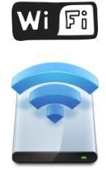

### How Wi-Fi Networks Works

Wi-Fi networks have **no physical wired connection** between sender and receiver by using radio frequency ([RF](http://www.webopedia.com/TERM/R/RF.html)) technology -- a frequency within the electromagnetic spectrum associated with radio wave propagation. When an RF current is supplied to an antenna, an electromagnetic field is created that then is able to propagate through space.

The cornerstone of any wireless network is an access point ([AP](https://www.webopedia.com/TERM/A/AP.html)). The primary job of an access point is to broadcast a wireless signal that computers can detect and "tune" into. In order to connect to an access point and join a wireless network, computers and devices must be equipped with wireless network adapters.

***The Wi-Fi Alliance***

The [*Wi-Fi Alliance*](http://www.webopedia.com/TERM/W/Wi_Fi_Alliance.html), the organization that owns the Wi-Fi registered trademark term specifically defines Wi-Fi as any "*wireless local area network (*[*WLAN*](http://www.webopedia.com/TERM/W/WLAN.html)*)*

*products that are based on the Institute of Electrical and Electronics Engineers' (*[*IEEE*](http://www.webopedia.com/TERM/I/IEEE.html)*) 802.11 standards.*"

Initially, Wi-Fi was used in place of only the **2.4GHz** [**802.11b**](http://www.webopedia.com/TERM/8/802_11.html) standard, however the [*Wi-Fi Allianc*e](http://www.webopedia.com/TERM/W/Wi_Fi_Alliance.html) has expanded the generic use of the Wi-Fi term to include any type of network or [WLAN](http://www.webopedia.com/TERM/W/WLAN.html) product based on any of the [802.11 standards](http://www.webopedia.com/TERM/8/802_11.html), including [802.11b](http://www.webopedia.com/TERM/8/802_11.html), [802.11a](http://www.webopedia.com/TERM/8/802_11.html), dual-band and so on, in an attempt to stop confusion about wireless LAN [interoperability](http://www.webopedia.com/TERM/I/interoperability.html).

### Wi-Fi Support in Applications and Devices

Wi-Fi is supported by many applications and [devices](http://www.webopedia.com/TERM/D/device.html) including [**video game**](http://www.webopedia.com/TERM/C/console_game.html)[**consoles**](http://www.webopedia.com/TERM/C/console_game.html)**, home** [**networks**](http://www.webopedia.com/TERM/N/network.html)**,** [**PDAs**](http://www.webopedia.com/TERM/P/PDA.html)**,** [**mobile phones**](http://www.webopedia.com/TERM/M/mobile_phone.html)**, major** [**operating**](http://www.webopedia.com/TERM/O/operating_system.html)[**systems**](http://www.webopedia.com/TERM/O/operating_system.html), and other types of [**consumer electronics**](http://www.webopedia.com/TERM/C/consumer_electronics.html)**.** Any products that are tested and approved as "Wi-Fi Certified" (a registered trademark) by the [Wi-Fi](http://www.webopedia.com/TERM/W/Wi_Fi_Alliance.html) [Alliance](http://www.webopedia.com/TERM/W/Wi_Fi_Alliance.html) are certified as [interoperable](http://www.webopedia.com/TERM/I/interoperability.html) with each other, even if they are from different manufacturers. For example, a user with a Wi-Fi Certified product can use any brand of [access point](http://www.webopedia.com/TERM/A/AP.html) with any other brand of client hardware that also is also "Wi-Fi Certified".

Products that pass this certification are required to carry an identifying seal on their packaging that states "Wi-Fi Certified" and indicates the [radio](http://www.webopedia.com/TERM/R/RF.html) [frequency](http://www.webopedia.com/TERM/R/RF.html) band used (2.5GHz for [802.11b](http://www.webopedia.com/TERM/8/802_11.html), [802.11g](http://www.webopedia.com/TERM/8/802_11.html), or [802.11n](http://www.webopedia.com/TERM/8/802_11.html), and 5GHz for [802.11a](http://www.webopedia.com/TERM/8/802_11.html)).

\***802.11** specifies an over-the-air interface between a wireless client and a base station or between two wireless clients.

**802.11** — applies to wireless LANs and provides 1 or 2 Mbps transmission in the 2.4 GHz band [**802.11b**](https://www.webopedia.com/TERM/8/802_11b.html) (also referred to as 802.11 High Rate or Wi-Fi) — an extension to 802.11 that applies to wireless LANS and provides 11 Mbps transmission in the 2.4 GHz band.

[**802.11a**](https://www.webopedia.com/TERM/8/802_11a.html) — an extension to 802.11 that applies to wireless LANs and provides up to 54-Mbps in the 5GHz band.

Source: <https://www.webopedia.com/TERM/W/Wi_Fi.html>

#### Actividades:

* Presta atención al título, subtítulos e imagen que acompaña al texto. ¿De qué trata el texto? ¿Cuál es la idea general?
* Presta atención a las palabras en negrita. ¿Qué significa la sigla **Wi-Fi**? ¿Cuál es la idea popular sobre su significado?
* Presta atención a las siglas **RF, AP, WLAN, IEEE** ¿A qué hacen referencia?
* **Wi-Fi Alliance** es propietaria del término Wi-Fi el cual es una marca registrada.

¿Es Wi-Fi Alliance una persona, una institución o una organización?

* En el texto se mencionan las siguientes cifras: 802.11, 802.11a y 802.1b. ¿Qué significan? (Utiliza la nota al pie de página).
* Uno de los subtítulos trata sobre aplicaciones and dispositivos. ¿En qué parte del texto se encuentra? ¿Cuáles menciona?
* Luego de aplicar la Estrategia del Vistazo ¿Qué porcentaje del texto has entendido?

**GUIA Nº 2**

What is a computer?

1 A **computer** is an electronic device that manipulates information, or data. It has the ability to **store**, **retrieve**, and **process** data. You may already know that you

3 can use a computer to **type documents**, **send email**, **play games**, and **browse the Web**. You can also use it to edit or

5 create **spreadsheets**, **presentations**, and even **videos**.

# Hardware vs. Software

* **Hardware** is any part of your computer that has a **physical structure**,

7 such as the keyboard or mouse. It also includes all of the computer's internal parts

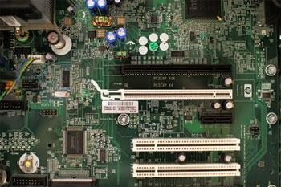

9 • **Software** is any **set of instructions** that tells the hardware **what to do** and **how to do it**. Examples of software include web browsers,

11 games, and word processors.

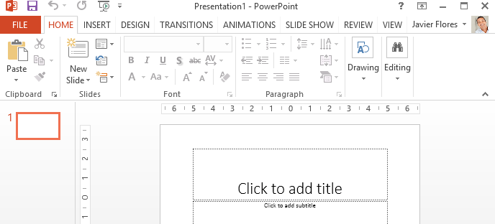

**Actividad I**: Lea el texto aplicando Estrategia del Vistazo y proporcione el Tema del texto.

**Actividad II**: Preste atención a las siguientes palabras del texto y escoja el significado más apropiado de acuerdo al contexto.

|  |  |  |  |  |
| --- | --- | --- | --- | --- |
| **LÍNEA** | **PALABRA** |  |  |  |
| 2 | **Retrieve** | rescatar | recuperar | reingresar |
| 3 | **Browse** | Echar un  vistazo | hojear | Navegar |
| 6 | **Any** | cualquier | algún | Ningún |
| 9 | **Set** | Grupo | establece | Conjunto |
| 10 | **Do** | dedicarse | hacer | Crear |

**Actividad III**: Una con flecha la información proporcionada en la columna A con las definiciones o características correspondientes de la columna B

|  |  |
| --- | --- |
|  | Un dispositivo electrónico que manipula información o datos |
| **SOFTWARE** | Buscadores, juegos y procesadores de texto. |
|  | Cualquier parte de la computadora que tiene una estructura física. |
| **COMPUTER** | Tiene la capacidad de almacenar, recuperar y procesar datos. |
|  | Partes interna de la computadora. |
| **HARDWARE** | Edita o crea hojas de cálculo, presentaciones e incluso videos |

**GUIA N° 3**

Ejercitación de uso de diccionario.

1. Busque el primer significado proporcionado por el diccionario de las siguientes palabras y la correspondiente categoría gramatical,

|  |  |  |
| --- | --- | --- |
| PALABRA | SIGNIFICADO | CAT. GRAMATICAL |
| OUTPUT |  |  |
| CONVERT |  |  |
|  |  |  |
| WORD |  |  |
| BUT |  |  |
| STORAGE |  |  |
| TAPE |  |  |
| PERFORM |  |  |
| PRINTER |  |  |
| DEVICE |  |  |
| QUICKLY |  |  |

1. Busque el significado de las siguientes palabras teniendo en cuenta la categoría gramatical especificada entre paréntesis.

|  |  |
| --- | --- |
| PALABRA | SIGNIFICADO |
| STORE(v) |  |
| WHOLE (s) |  |
| RECORD (v) |  |
| RECORD (s) |  |
| RATE (s) |  |
| RATE (V) |  |
| WHILE (CONJ.) |  |
| REACH (s) |  |
| WORK (V) |  |

1. Busque las siguientes palabras de acuerdo a la rama de la ciencia y la técnica especificada entre paréntesis.

|  |  |
| --- | --- |
| PALABRA | SIGNIFICADO |
| Storage (comp) |  |
| Key (elect) |  |
| Power (mat.) |  |
| Mute(música) |  |
| Ring (joy) |  |

1. Proporcione el singular de las siguientes palabras

|  |  |
| --- | --- |
| **PLURAL** | **SINGULAR** |
| **INDICES** | **………………………………………….** |
| **LEAVES** | **………………………………………….** |
| **DATA** | **………………………………………….** |
| **FORMULAE** | **…………………………………………..** |
| **WOMEN** | **……………………………………………** |
| **PROPERTIES** | **…………………………………………..** |
| **BACTERIA** | **………………………… …………………** |

1. Busque el significado de las siguientes expresiones

|  |  |
| --- | --- |
| **EXPRESIONES** | **SIGNIFICADO** |
| 1. so on | ……………………………………………… |
| 2. as regards to | ……………………………………………… |
| 3. by far | ……………………………………………… |
| 4. at least | ……………………………………………… |
| 5. neither… nor | ……………………………………………… |
| 6. such as | …………………………………… |
| 7. on the other hand | ……………………………………………… |

1. En las siguientes oraciones, busque el significado de las palabras resaltadas aplicando las reglas de búsqueda en diccionario. Luego interprete las mismas
   1. Computers are electronic **machines**.
   2. There are three different **kinds** of computers.
   3. They operate **quickly** and **accurately** in solving problems**.**
   4. The memory unit **stores** the data and the programs.
   5. The **output** device converts electronic pulses into information.
   6. The collection of **addresses** in the network is called the address space.
   7. The **largest** computers can perform millions of calculations.
   8. Parts of a number **smaller** than 1 are sometimes **expressed** in terms of fractions.
   9. The **bigger** computers are also **known** as mainframes.

**GUÍA Nº 4**

Actividad I:

1. Centra tu atención en el siguiente texto y aplica la **estrategia del vistazo**
2. Identifica palabras en **negrita**, *cursiva,* palabras repetidas, palabras transparentes, siglas y otros indicadores que te ayuden a inferir la idea central del texto.
   * ¿Qué partes de la computadora analizaremos?

Antes de leer en detalle cada sección analicemos que conocemos sobre cada una de estas partes ¿qué puedes decir sobre el funcionamiento y el uso de las mismas?

**Basic parts of a computer**

1 The basic parts of a desktop computer are the **computer case, monitor, keyboard, mouse, and power cord**. Each part plays an **important role**

3 whenever you use a computer.

#### Computer case

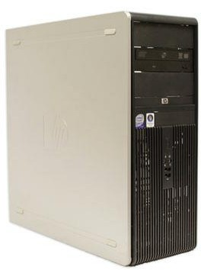

The **computer case** is the metal and plastic box that **contains the main**

5 **components** of the computer, including the motherboard, central processing unit (CPU), and power supply. The front of the case usually has an **On/Off**

7 **button** and one or more **optical drives**.

Computer cases come in different shapes and sizes. A **desktop case** lies on a

9 desk, and the m*onitor* usually sits on top of it. **A tower case** is tall and sits next to the monitor or on the floor. **All-in-one** computers come with the internal

11 *components* built into the monitor, which eliminates the need for a separate case.

#### **Monitor**

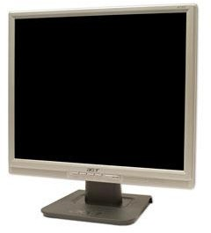

13 **The monitor** works with a video card, located inside the computer case, to display images and text on the screen. Most monitors have **control buttons**

15 that allow you to change your monitor's display settings, and some monitors also have built-in speakers.

17 Newer monitors usually have **LCD** (liquid crystal display) or **LED** (light-emitting diode) displays. These can be made very thin, and they are often called **flat-**

19 **panel displays**. Older monitors use **CRT** (cathode ray tube) *displays*. CRT monitors are much larger and heavier, and they take up more desk space.

**Keyboard**

21 The **keyboard** is one of the main ways to communicate with a computer. There are many different types of keyboards, but most are **very similar** and allow you

23 to accomplish the same basic tasks.

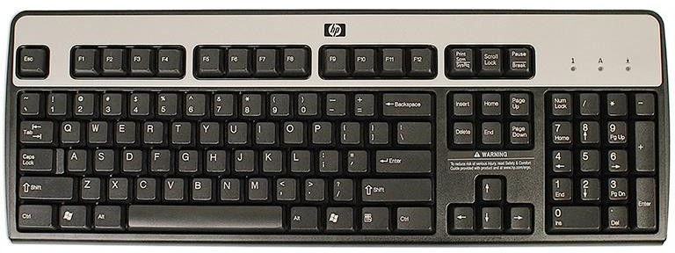

## Mouse

The **mouse** is another important tool for communicating with

25 computers. Commonly known as a **pointing device**, it lets

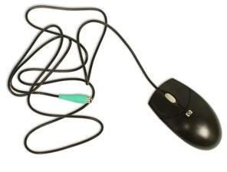you **point** to objects on the screen, **click** on them, and **move** them.

27 There are two main mouse types: *optical and mechanical*.

The **optical** mouse uses an electronic eye to detect movement and

29 is easier to clean. The **mechanical mouse** uses a rolling ball to detect movement and requires regular cleaning to work properly.

## Mouse alternatives

31 There are other devices that can do the same thing as a mouse. Many people find them **easier to use**, and they also require less desk space than a

33 traditional mouse. The most common mouse alternatives are below.

**Trackball**: A trackball has a ball that **can rotate** freely. Instead of moving the

35 device like a mouse, you can roll the ball with your thumb to move the pointer

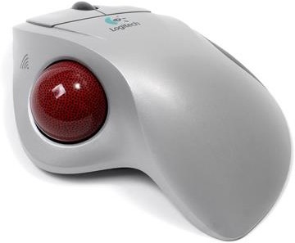

**Touchpad:** A touchpad—also called a **trackpad**—is a touch-sensitive pad that

37 lets you control the pointer by making a drawing motion with your finger. Touchpads are common on laptop computers.

Source:[https://www.gcflearnfree.org/computerbasics/basic-parts-of-a-](https://www.gcflearnfree.org/computerbasics/basic-parts-of-a-computer/1/) [computer/1/](https://www.gcflearnfree.org/computerbasics/basic-parts-of-a-computer/1/)

**Actividad II**: Aplique Estrategia de la **Inferencia** y deduzca significado de las siguientes palabras:

|  |  |  |  |  |
| --- | --- | --- | --- | --- |
| **LINEA** | **PALABRA** |  |  |  |
| **1** | **DESKTOP** | personal | De escritorio | De madera |
| **2** | **POWER** | energía | potencia | fuerza |
| **8** | **SHAPES** | Estilos | maneras | formas |
| **8** | **LIES** | descansa | yace | Se apoya |
| **9** | **SITS** | Se sienta | Se ubica | Se posa |

**Actividad III:** Analicemos ahora las frases nominales que contiene le texto bajo los subtítulos “Basic parts of a computer”, “Computer case” and Monitor”:

1. Identifíquelas en el mismo
2. Márqueles el Núcleo
3. Proporcione su equivalente Castellano

1) The basic parts (L. 1) : Las partes básicas

2) The computer case (L.1): La caja de la computadora

3) An important role (L. 3): Un rol importante

4) the metal and plastic box (L.4)…………………………………….

5) The main components (L.5) ……………………………………….

6) Central processing unit (L.5)………………………………………

7) An On/Off button(L. 7)………………………………………………

8) One or more devices (L.7)………………………………………..

**** Vamos a leer información sobre **AFIJOS**!!!+

**Actividad IV**: Busquemos palabras con sufijos en el texto y agrupémoslos según la categoría gramatical.

|  |  |  |  |
| --- | --- | --- | --- |
| **SUSTANTIVOS** | **ADJETIVOS** | **ADVERBIOS** | **VERBOS** |
|  |  |  |  |
|  |  |  |  |
|  |  |  |  |
|  |  |  |  |
|  |  |  |  |
|  |  |  |  |
|  |  |  |  |
|  |  |  |  |

**Actividad V**: Analizaremos las siguientes oraciones. Identificamos el verbo y luego las separamos en Sujeto y Predicado. Interpretémoslas ayudándonos con el diccionario si fuese necesario

**| |** = frase nomial

Sujeto Predicado

* 1. [ The keyboard ] [ is one of the main ways to communicate with a computer.]

El teclado es una de las principales formas para comunicarse con una computadora

Sujeto

* 1. [The mouse] is another important tool.

El mouse es otra importante herramienta

* 1. The instructions and data are called software.
  2. It is an internal component of the computer
  3. All general-purpose computers require hardware components.
  4. All-in-one computers come with the internal components

Las computadoras Todo-en-Uno vienen con componentes internos

* 1. Monitors have control buttons.

Los monitores tienen botones de control

* 1. The optica**l** mouse uses an electronic eye to detect movement and is easier to clean.

El mouse óptico usa un ojo electrónico para detectar movimientos y es más fácil de limpiar

* 1. The monitor works with a video card.

El monitor funciona con una tarjeta de video

Sujeto predicado

* 1. [ A touchpad—also called a trackpad— ] [ is a touch-sensitive pad ].
     + ¿Consideras importante realizar esta actividad? ¿Por qué?

**Actividad IV**: Completa los espacios en blanco con información del texto. Ayúdate con el diccionario

a) Las partes básicas de una computadora de escritorio son: …………………………...

………………………………………………………………………………………….. b) El gabinete es…………………………………………………………………………..

……………………………………………………… que incluye…………………….

………………………………………………………………………………………….. c) Los gabinetes vienen en ……………………………………………………………….

d) El monitor trabaja con ………………………………………………………………….

…………………………………………………………………………………………..

e) Hay dos tipos principales de mouse: …………………………………………………

f) El mouse óptico…………………………………………………………………………

………………………………………………………………………………………….. g) Hay otros dispositivos que……………………………………………………………...

………. Ellos son:………………………………………………………………………

**GUIA N° 5**

**Operating system – OS**

1 The ***o****perating* ***s****ystem (****OS****)* is the most important program that runs on a computer. Every general-purpose computer must have an operating system to

3 run other programs and [applications](http://www.webopedia.com/TERM/A/application.html). Computer operating systems perform basic tasks, such as recognizing input from the [keyboard](http://www.webopedia.com/TERM/K/keyboard.html), sending output to the

5 display screen, keeping track of files and directories on the storage drives, and controlling [peripheral devices](http://www.webopedia.com/TERM/P/peripheral_device.html), such as printers.

7 For large systems, the operating system has even greater responsibilities and powers. It is like a traffic cop — it makes sure that different programs

9 and [users](http://www.webopedia.com/TERM/U/user.html) running at the same time do not interfere with each other. The operating system is also responsible for [*security*](http://www.webopedia.com/TERM/S/security.html), ensuring that unauthorized

11 users do not [access](http://www.webopedia.com/TERM/A/access.html) the system.

For [PCs](http://www.webopedia.com/TERM/P/personal_computer.html), the most popular operating systems are **DOS**, [**OS/2**](https://www.webopedia.com/TERM/O/OS_2.html), and [**Windows**](http://www.webopedia.com/TERM/W/Windows.html),

13 but others are available, such as [**Linux**](http://www.webopedia.com/TERM/L/Linux.html).

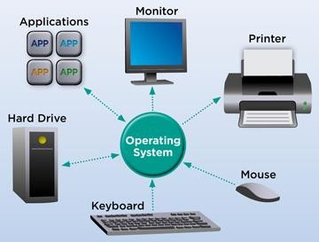

***Image: Operating System Diagram***

***Classification of Operating systems***

* [**Multi-user**](http://www.webopedia.com/TERM/M/multi_user.html)**:** Allows two or more users to run programs at the same time.

15 Some operating systems permit hundreds or even thousands of concurrent users.

17  [**Multiprocessing**](http://www.webopedia.com/TERM/M/multiprocessing.html)**:** Supports running a program on more than one [CPU](http://www.webopedia.com/TERM/C/CPU.html).

* [**Multitasking**](http://www.webopedia.com/TERM/M/multitasking.html)**:** Allows more than one program to run concurrently.

19  [**Multithreading**](http://www.webopedia.com/TERM/M/multithreading.html)**:** Allows different parts of a single program to run concurrently.

21  [**Real time**](https://www.webopedia.com/TERM/R/real_time.html)**:** Responds to input instantly. General-purpose operating systems, such as [DOS](http://www.webopedia.com/TERM/D/DOS.html) and [UNIX](https://www.webopedia.com/TERM/U/UNIX.html), are not real-time.

###### User Interaction With the OS

23 As a user, you normally interact with the operating system through a set of [**commands**](http://www.webopedia.com/TERM/C/command.html). For example, the DOS operating system contains commands

25 such as COPY and RENAME for [copying](http://www.webopedia.com/TERM/C/copy.html) files and changing the [names](http://www.webopedia.com/TERM/N/name.html) of files, respectively. The commands are accepted and [executed](http://www.webopedia.com/TERM/E/execute.html) by a part of the

27 operating system called the [command processor](http://www.webopedia.com/TERM/C/command_processor.html) or command line interpreter. [**Graphical user interfaces**](http://www.webopedia.com/TERM/G/Graphical_User_Interface_GUI.html) allow you to enter commands by

29 pointing and [clicking](http://www.webopedia.com/TERM/C/click.html) at [objects](http://www.webopedia.com/TERM/O/object.html) that appear on the screen.

Most Popular Desktop Operating Systems

31 The three most popular types of operating systems for personal and business computing include Linux, Windows and Mac.

33 **Windows**

[Microsoft Windows](http://www.webopedia.com/TERM/M/Microsoft_Windows.html) is a **family** of operating systems for personal and business

35 computers. Windows dominates the personal computer world, offering a graphical user interface (GUI), virtual memory management, multitasking, and

37 support for many peripheral devices.

**Mac**

39 Mac OS is the **officia**l name of the [Apple Macintosh operating system](http://www.webopedia.com/TERM/M/Macintosh_computer.html). It features a graphical user interface (GUI) that utilizes windows, icons, and all

41 applications that run on a Macintosh computer have a similar user interface.

Linux

43 [Linux](http://www.webopedia.com/TERM/L/Linux.html) is a freely distributed open source operating system that runs on a number of hardware platforms. The Linux kernel was developed mainly by Linus

45 Torvalds and it is based on Unix.

According to Netmarketshare.com, the most used desktop operating system

47 and versions used on PCs in July 2017 are:

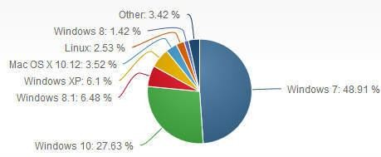

***Image Source:*** *Desktop Operating System Market Share (*[*Net Applications.com, July 2017*](https://www.netmarketshare.com/operating-system-market-share.aspx?qprid=10&qpcustomd=0)*)*

**Actividad I**: Lea el texto aplicando **Estrategia del Vistazo** Identifique palabra transparentes, palabras conocidas, preste atención a número e imágenes.

¿Cuál es el **TEMA** del texto?

**Actividad II:** Busque en el diccionario el significado y la categoría gramatical de las siguientes palabras. Tenga en cuenta la ubicación de las mismas en la oración

a. Runs (L. 1)………………………………………………………….

b. Output (L. 4) ……………………………………………………….

c. Greater (L. 7) ………………………………………………………

d. Cop (L. 8)…………………………………………………………..

e. Available (L. 13)…………………………………………………….

**ACTIVIDAD III**: Trabajemos con las frases nominales de los dos primeros párrafos. Busque en los mismos frases nominales de **tres o más elementos**. (Ayudémosnos con los sufijos y marcadores)

1. …………………………………………………………………………………

2.

3. …………………………………………………………………………………

4. …………………………………………………………………………………

5. …………………………………………………………………………………

6. ………………………………………………………………………………….

7. …………………………………………………………………………………

8. ………………………………………………………………………………….

9. ………………………………………………………………………………

**ACTIVIDAD IV**: Prestemos atención a las palabras con terminación **-ing.**

¿Recuerdas cómo se buscan estas palabras en el diccionario? ¿Con qué categoría gramatical?

☺ Analicemos ahora su **función gramatical** dentro de la oración.

**ACTIVIDAD V**: Completa el cuadro con la función gramatical y significado adecuado de las siguientes palabras terminadas en **-ing.**

|  |  |  |  |
| --- | --- | --- | --- |
| **LÍNEA** | **PLABRA** | **FUNCIÓN GRAMAT.** | **SIGNIFICADO** |
| 1 | operating |  |  |
| 4 | recognizing |  |  |
| 4 | sending |  |  |
| 9 | running |  |  |
| 10 | ensuring |  |  |
| 29 | copying |  |  |
| 29 | changing |  |  |
| 35 | pointing and changing |  |  |
| 36 | computing |  |  |
| 39 | offering |  |  |
| 40 | Multitasking |  |  |

**Actividad VI**: Presta atención a las siguientes frases:

Línea 30 are accepted and executed Línea 48 was developed

Línea 49 is based Línea 55 are designed

* ¿Qué encuentras en común entre ellas?
* ¿Qué sabes de la voz pasiva?

**Actividad VII**: Trabaja con **referentes contextuales** bajo el subtítulo “Most popular desktop operating systems”

**Actividad VIII**: Ayudándote con todas las actividades anteriores, vamos a contestar preguntas y completar cuadros con información del texto.

1. ¿Qué es un “operating system?
2. ¿Qué tareas realiza el Sistema operativo de una computadora?
3. ¿De qué otra cosa también es responsable el Sistema operativo?
4. Menciona los sistemas operativos más importantes.
5. ¿Cómo se clasifican los sistemas operativos? Completa el gráfico:

…………………………………………………….

 ……………………………………………………..  ……………………………………………………..  ……………………………………………………….

**Actividad IX**: Proporciona una pequeña reseña de los sistemas operativos

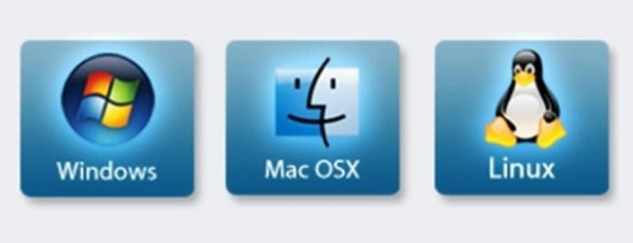

**GUÍA N° 6**

**Actividad I:** Presta atención al título y subtítulos del siguiente texto, observa las imágenes que lo acompañan y otros indicadores que te ayuden a predecir el contenido del texto. ¿De qué crees que se trate el mismo?

* ¿Qué conoces sobre la **nube virtual**? ¿La utilizas? ¿Con qué frecuencia y con qué propósitos?

## What is the cloud?

1 You may hear people using terms like **the cloud, cloud computing**, or **cloud storage**. But what exactly is the cloud?

3 The cloud is **the Internet**—more specifically, it is all of the things you can

**access remotely** over the Internet. When something is **in the cloud**, it means it

5 is stored on **Internet servers** instead of your computer's hard drive.

##### Why use the cloud?

7 Some of the main reasons to use the cloud are **convenience** and **reliability**. For example, if you have ever used a **web-based email service**, such as

**Gmail** or **Yahoo! Mail**, you have already used the cloud. All of the emails in a

9

web-based service are stored on servers rather than on your computer's hard

11 drive. This means you can access your email from any computer with an Internet connection. It also means you will be able to recover your emails if

13 something happens to your computer.

Let's look at some of the most common reasons to use the cloud.

15 • ***File storage***: You can store all types of information in the cloud, including files and email. This means you may access these things from **any**

17 **computer** or **mobile device** with an Internet connection, not just your home

computer. **Dropbox** and **Google Drive** are some of the most popular cloud-

19 based storage services.

* ***File sharing***: The cloud makes it easy to share files with several people

21 at the same time. For example, you could upload several photos to a cloud- based photo service like **Flickr** or **iCloud Photos**, then quickly share them with

23 friends and family.

* ***Backing up data***: You can also use the cloud to protect your files. Apps

25 like **Mozy** and **Carbonite** automatically back up your data to the cloud. This way, if your computer ever is lost, stolen, or damaged, you will still be able to

27 recover these files from the cloud.

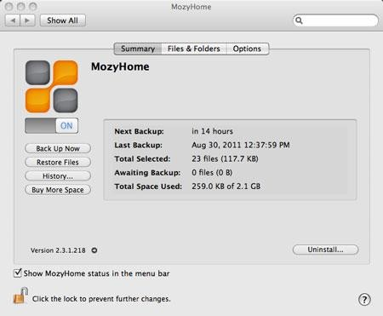

##### What is a web app?

Previously, we talked about how **desktop applications** allow you to perform

29 tasks on your computer. But there are also **web applications**—or web apps— that run in the cloud and do not need to be installed on your computer. Many of

31 the most popular sites on the Internet are actually web apps.

Let's take a look at some popular web apps.

* ***Facebook***: Facebook lets you create an online **profile** and interact with

33 your friends. Profiles and conversations can be updated at any time, so Facebook uses web app technologies to keep the information updated.

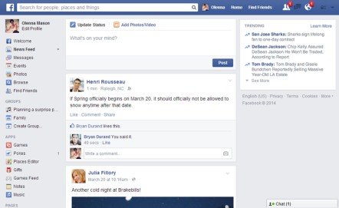

* ***Pixlr:*** Pixlr is an **image editing application** that runs in your web

35 browser. Much like **Adobe Photoshop**, it includes many advanced features, like color correction and sharpening tools.

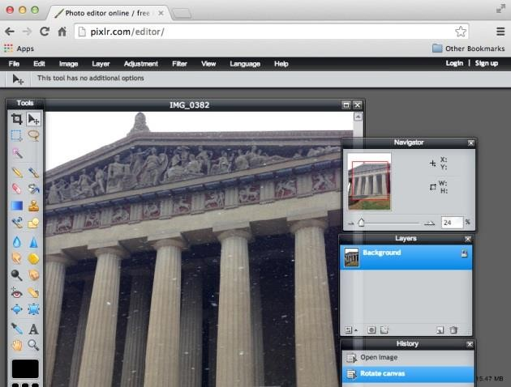

37 • ***Google Docs***: Google Docs is an **office suite** that runs in your browser. Much like **Microsoft Office**, you can use it to create **documents,**

39 **spreadsheets, presentations**, and more. And because the files are stored in the cloud, it is easy to share them with others.

**Actividad II**: Observa las siguientes palabras. Indica su categoría gramatical (Sustantivo, adjetivo o adverbio) y su significado.

* Usa el diccionario cuando sea necesario.
* Presta atención a los sufijos. Recuerda quitar el sufijo para facilitar la búsqueda en el diccionario.

|  |  |  |  |
| --- | --- | --- | --- |
| **Línea** | **Palabra** | **Significado** | **Categoría**  **gramatical** |
| 1 | Computing |  |  |
| 4 | Remotely |  |  |
| 7 | Convenience |  |  |
| 7 | Reliability |  |  |
| 16 | Means |  |  |
| 20 | Several |  |  |
| 21 | Same |  |  |
| 21 | Quickly |  |  |
| 25 | Able |  |  |
| 32 | Interact |  |  |
| 34 | Technologies |  |  |
| 35 | Browser |  |  |
| 36 | Advanced |  |  |

**Actividad II**: Observa las siguientes frases nominales tomadas del texto. Identifica su núcleo y modificadores. ¿Qué tienen en común?

Línea The most common reasons

Línea The most popular cloud-based storage services

Linea The most popular sites

1. Ahora observa las siguientes oraciones. Brinda su equivalente al castellano

Google Drive is more popular than Flickr Windows 7 is more useful than Windows 93

Apple phones are more expensive than Samsung phones

1. Compara ambas listas. ¿Qué diferencias encuentras?

**Actividad IV**: A continuación identifica en el texto, frases nominales de tres o más elementos.

**Actividad V**: Ahora trabajemos con verbos y frases verbales.

1. Observa los siguientes verbos e indica su significado. Luego comenta con la clase qué estrategias utilizaste. ¿Tuviste que quitar algunos sufijos?

¿Cuáles?

|  |  |  |  |
| --- | --- | --- | --- |
| **Línea** | **Verbo** | **Línea** | **Verbo** |
| 1 | Hear | 27 | Talked |
| 3 | Access | 29 | Need |
| 4 | Stored | 29 | Installed |
| 7 | Use | 32 | Updated |
| 12 | Happens | 34 | Runs |
| 22 | Back up | 40 | Share |

**Actividad VI**: Presta atención a las siguientes frases verbales Línea 1 may hear

Línea can acces

A los fines de la traducción es lo mismo pero hay una diferencia entre ambos

verbos modales:

***CAN***: significa **PODER** y expresa **HABILIDAD**

***MAY***: significa **PODER** pero expresa **POSIBILIDAD**

Ahora podemos identificar más frases verbales en el texto que incluyan **verbos modales**. Utiliza la información de las **actividades V y VI** y la teoría de Verbos modales para ayudarte.

**Actividad VII**: Trabajemos con referentes. Observa las palabras subrayadas en el texto e indica con una flecha a que parte del texto hacen referencia las mismas.

**Actividad VIII**: Responde en Castellano las siguientes preguntas:

* 1. Proporcione la definición de “cloud”
  2. ¿Qué significa que algo “esté en la nube”?
  3. ¿Dónde son almacenados los e-mails? ¿Qué implica esto?
  4. Mencione las razones más comunes para usar la nube
  5. ¿Cuáles son los servicios de almacenamiento basados en la nube más populares?
  6. ¿Cuál es la utilidad del “backing up data”?
  7. ¿Qué es una Web application?
  8. Complete el siguiente cuadro acerca de las aplicaciones Web



Facebook

* definición
* características



Pixlr

* definición
* características



Google Docs

* definición
* caraterísticas

**GUÍA N° 7**

**Actividad I**: Lee el siguiente texto aplicando la Estrategia del Vistazo y proporciona el **tema** del mismo. Utiliza las imágenes para ayudarte.

## What is a mobile device?

1 A mobile device is a general term for any type of **handheld computer**. These devices *are*

*designed* to be extremely portable, and they *can often fit* in your hand. Some mobile

3

devices—like **tablets**, **e-readers**, and **smartphones**—are powerful enough to do many of

the same things you *can do* with a desktop or laptop computer.

### Tablet computers

5

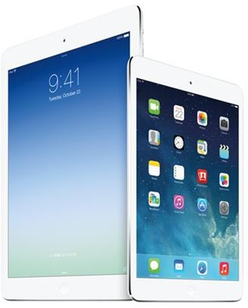Like laptops, **tablet computers** *are*

7

*designed* to be portable. However, they

provide a different computing experience.

9 The most obvious difference is that tablet computers *do not have* keyboards or

11 touchpads. Instead, the entire screen is touch-sensitive, allowing you to type on

13 a **virtual keyboard** and use your finger as

a mouse pointer.

15

Tablet computers *can not necessarily do* everything traditional computers *can do*. For many

17

people, a traditional computer like a **desktop** or **laptop** *is still needed* in order to use some

19 programs. However, the convenience of a tablet computer means it *may be* ideal as a **second computer**.

### E-readers

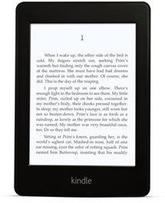**E-book readers**—also called **e-readers**—are

23 similar to tablet computers, except they *are mainly designed* for reading **e-books** (digital,

25 downloadable books). Notable examples include

the Amazon Kindle, Barnes & Noble Nook,

27

and **Kobo**. Most e-readers use an **e-ink** display,

which is easier to read than a traditional computer

29

display. You *can even read* in bright sunlight, just like if you *were reading* a regular book.

31

You *do not need* an e-reader to read e-books. They *can also be* read

on **tablets**, **smartphones**, **laptops**, and **desktops**.

33 ***Smartphones***

A smartphone is a more powerful version of a traditional cell phone. In addition to the same

35 basic features—phone calls, voicemail, text messaging—smartphones *can* ***connect* to the Internet** over Wi-Fi or a cellular network (which requires purchasing a monthly **data plan**).

37

This means you **can use** a smartphone for the same things you *would normally do* on a computer, such as checking your email, browsing the Web, or shopping online.

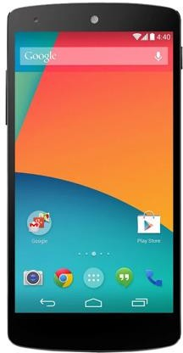

39 Most smartphones use a **touch-sensitive screen**, meaning there is not a physical keyboard on the device. Instead, you *will type* on a virtual keyboard and use your fingers to interact

41 with the display. Other standard features include a high-quality digital camera and the ability

to play digital music and video files. For many people, a smartphone *can actually replace*

43

electronics like an old laptop, digital music player, and digital camera in the same device.

**Actividad II**: Vuelve a leer el texto ahora aplicando la Estrategia de la Inferencia y determina el significado de los siguientes términos y su categoría gramatical. Utiliza el diccionario como último recurso.

|  |  |  |
| --- | --- | --- |
| **PALABRAS** | **SIGNIFICADO** | **CAT. GRAMATICAL** |
| Handheld |  |  |
| Pointer |  |  |
| Second |  |  |
| Downloadable |  |  |
| Display |  |  |
| E-readers |  |  |
| Powerful |  |  |
| Data |  |  |
| Features |  |  |
| Old |  |  |
| Sensitive |  |  |

**Actividad III:** Ahora analicemos las siguientes frases nominales. Brinda su equivalente al castellano.

A paper book a digital book

A desktop computer a handheld computer

A mouse pointer a light pointer

Computer display a traditional display

A computer keyboard a virtual keyboard

Keyboard shortcuts a physical keyboard

A laptop computer an old laptop

1. ¿Qué puedes observar sobre los **modificadores** del sustantivo de la **primera columna** con respecto a los que se encuentran en la segunda columna?
2. ¿Qué puedes decir sobre las 2 últimas frases comparadas en ambas columnas? ¿Cuál es la

**categoría gramatical** de la palabra que se repite? ¿Cuál es la **función gramatical**?

1. ¿Puedes ahora buscar otras frases nominales? Presta atención a los sufijos y los marcadores que delimitan su comienzo y final.

** Ahora leamos información sobre verbos y frases verbales**

**Actividad IV**: Trabajemos con los verbos y frases verbales del texto. Identifiquemos que frases están en Voz **Activa** y cuáles en Voz **Pasiva**

**Actividad V:** Responde con información del texto

* 1. **¿**Qué es un dispositivo móvil? ¿Qué se dice respecto a su tamaño?
  2. ¿Cuál es la diferencia entre una Tablet y una Laptop?
  3. Interprete la información sobre E-Readers
  4. Mencione las características básicas y especiales de un Smatphone
  5. ¿Qué implica el uso de una pantalla sensible al tacto?
  6. ¿Qué tipo de artefactos electrónicos puede reemplazar un smartphone?

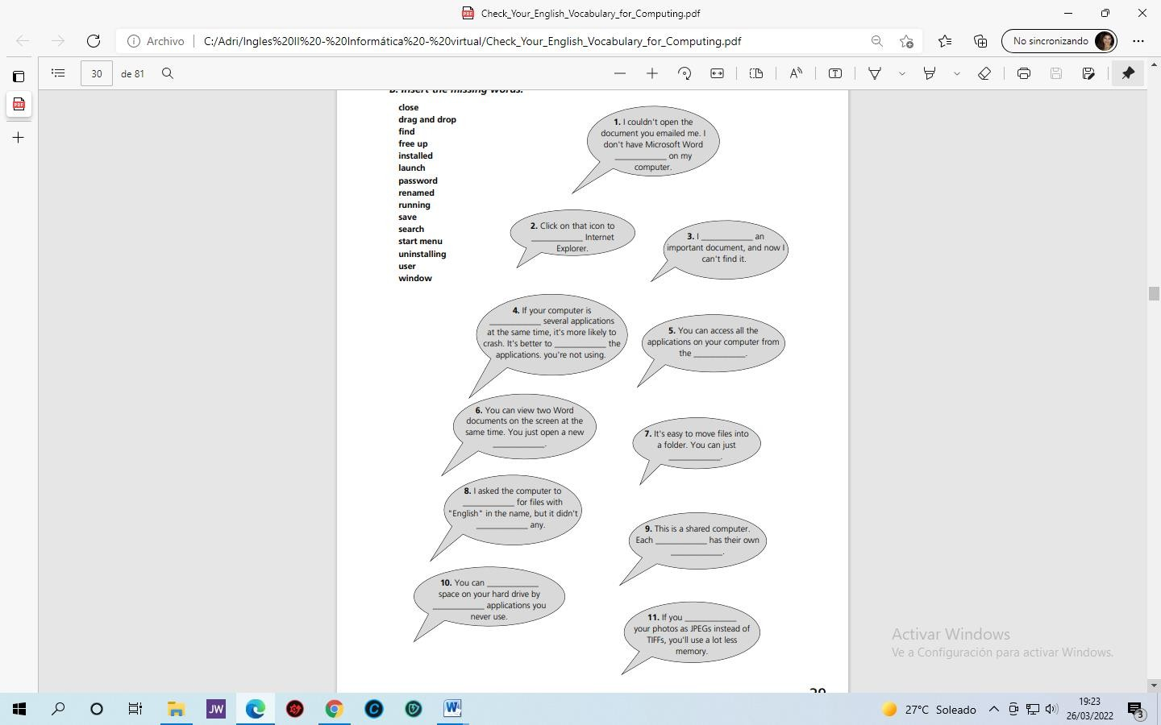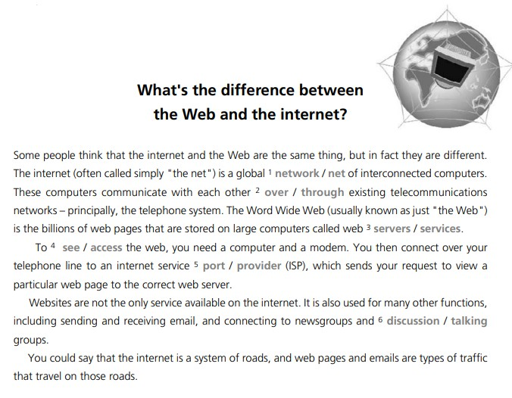

**GUÍA N° 8**

**Actividad I**: Lee el siguiente texto y escoge la opción correcta de las palabras en gris. Emplea el diccionario cuando sea necesario.

**Actividad II**: Une las actividades con las funciones de Internet.

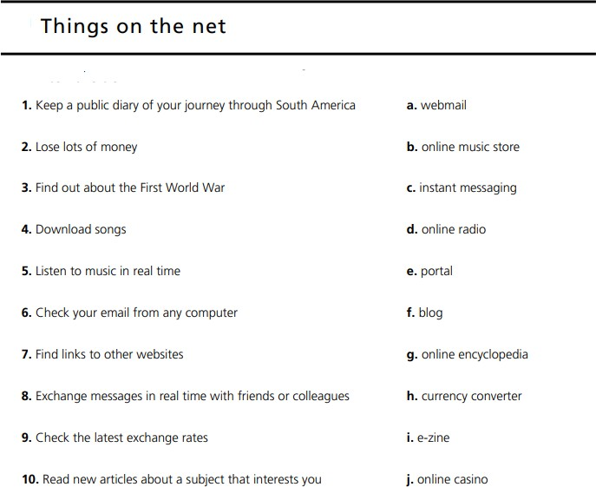

**Actividad III**: Completa los globos de dialogo con una palabra de la lista.

Para ello debemos tener en cuenta varios aspectos: significados, estructuras gramaticales, categorías gramaticales y sufijos, integrando así nuestros conocimientos adquiridos hasta ahora.

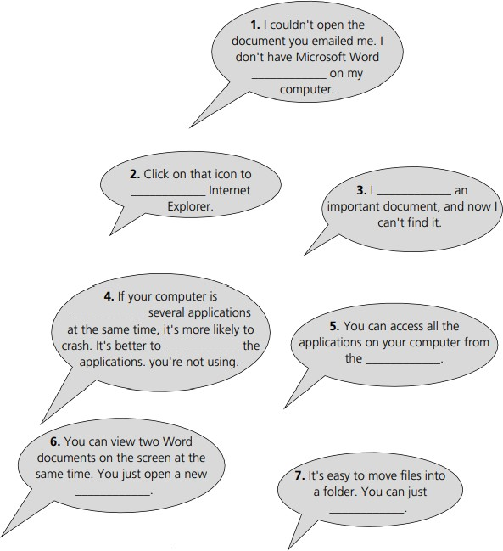

**close**

**drag and drop find**

**free up installed launch password renamed running save search start menu**

**uninstalling user window**

